This web based map application tested on Firefox and Google Chrome, also its available on online server at this link <http://mapassignment.esy.es/> .

1. Base layers shown transport in Dublin city.

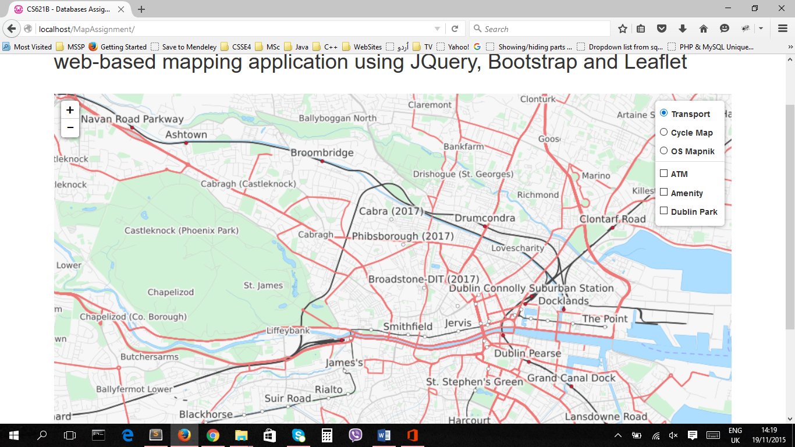

1. Base layer shown cycle track map in Dublin city.

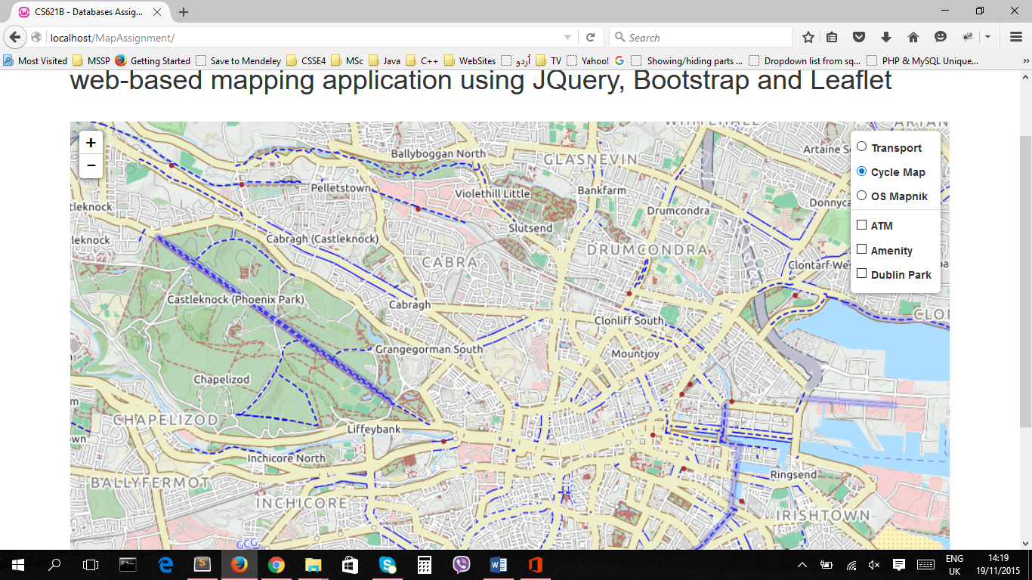

1. Base layer shown map view of Dublin city

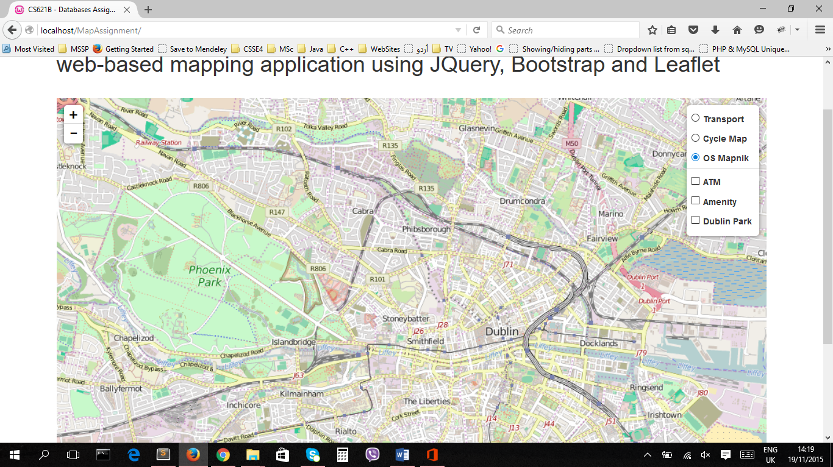

1. overlay GeoJSON layers. Shown ATM location in Dublin city. With amenity type, name, and operator. (note all node have not fully information) .

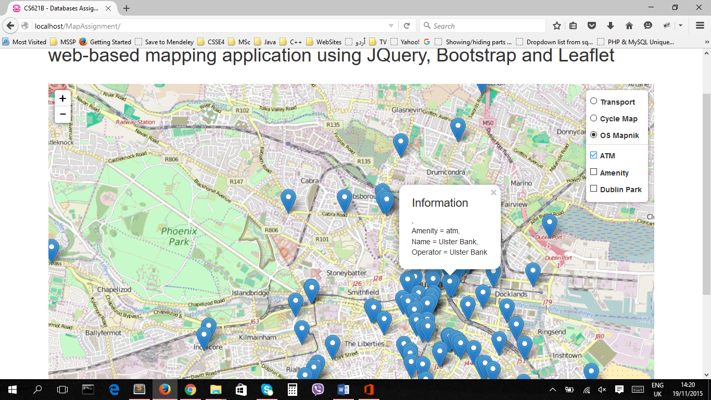

1. overlay GeoJSON layers, create polygon around school, parking, park, place of worship and fountain. (here also some nodes and polygon don’t have full information)

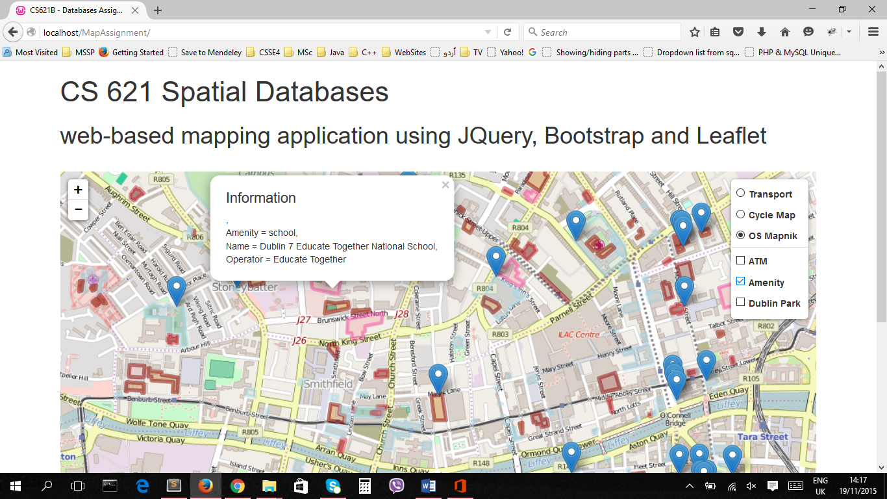

1. as previous point shown park in Dublin.

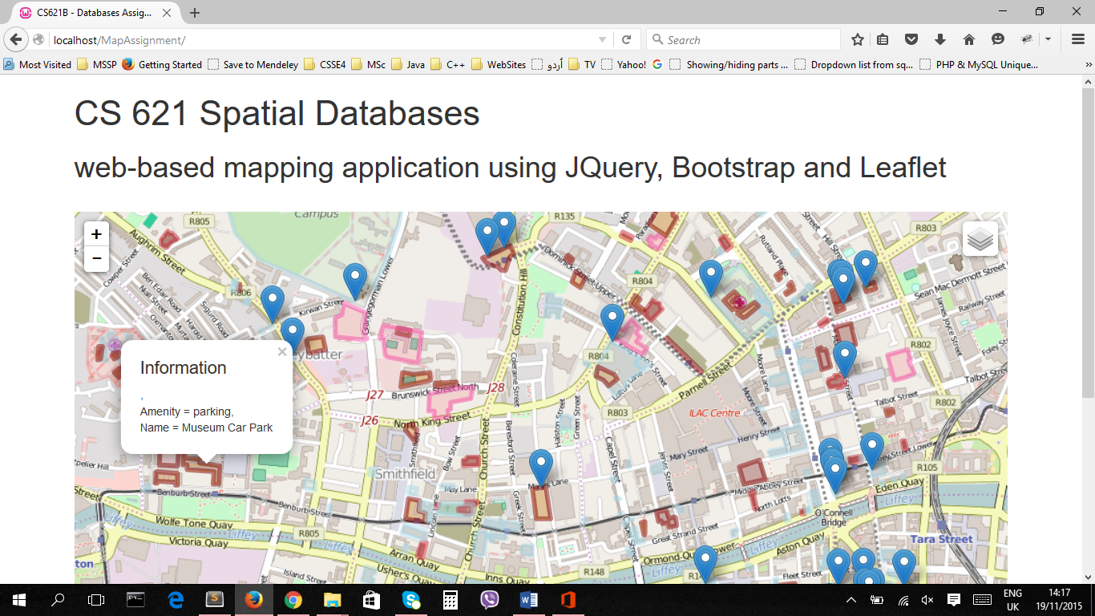

1. overlay GeoJSON, created by self, two polygon created 1st around Phoenix park and 2nd around TCD university Dublin. Where each shown amenity type and name.

